**UNNIVERSITY ADMISSION PROCESS SYSTEM**  (UML diagrams)

CONTENTS

TOPIC

**1. INTRODUCTION**

**2. PROJECT DESCRIPTION**

**3. MODULE DESCRIPTION**

**4. UML DIAGRAMS**

**5. CONCLUSION**

**1. INTRODUCTION**

University Admission Management System is a web-based application built with the aim of computerizing the admission procedure in universities and colleges. The system proposed here incorporates handling and management of multi-departmental and multi-divisional system that includes various daily activities in the system plays a vital part of any university’s running because students are what keep an university alive. The student admission is one of the most important activities within an university as one cannot survive without a students. A poor admission system can mean fewer students being admitted into a university because of mistakes or an overly slow response time.

The process begins with the potential student completing an application form through the university’s admission service . The first step for students is to apply directly to the university through a custom form. The next step is for the admission service centre has to review the application and ensure that all of the required information has been provided, from the form itself to the supplementary documentation, such as language and degree certificates. If any of the required information is missing it is the secretary for the department to which the application concerns that contacts the potential student and arranges for the delivery of the outstanding data. The application in its entirely is then forwarded, complete with a recommendation, to the respective departments admissions tutor who has the final say as to whether each potential student is accepted or rejected.

**PURPOSE :**

A computerized admission system is the need and demand of every [university](http://www.codewithc.com/university-management-system-project-c/) today. To reach out to students at every nook and corner of the world, a computerized works way better than manual pen-paper system.This project is developed for the purpose of computerization of admission procedure in universities to reduce the time and manpower required in manual admission process. The key **features**  of the system is outlined below:

* Paperless admission with computerized process
* Reduced time in activities with reduced manpower
* Economy
* Operational efficiency
* Effective integration with other institutions

**SCOPE:**

The project scope is to automate the system, pre-checking the inclusion of all required material and automatically ranking each students application based on a number of criteria. The criteria include the ranking of their university, their grades at said university and their language grade certificate. The data used by the system is stored in a database that will be the center of all information held about students and the base for the remainder of the process after the initial application has been made. This enables things to be simplified and considerably quickened, making the jobs of the people involved easier. It supports the current process but centralizes it and makes it possible for decisions to be made earlier and easier way.

**2. PROJECT DESCRIPTION**

In this project ,we deals with the actual process that is going in the HUNIVERSITY ADMISSION PROCESS SYSTEM. Here we are drawing the UML diagrams for the project based on the process and criteria that is actually going in there. Here we have used CLASS, USECASE, ACTIVITY, SEQUENCE diagrams to show the working of the system.

This project consists of the process like filling admission forms ,selecting courses, fee payments,entrance exams .Our project consists of some modules which are given below:

**Modules:**

### . Modules Overview:

### 1. Admission form,

### 2.Seats availability,

### 3.Administrator,

### 4.Fee payment.

### 3. MODULE DESCRIPTION:

**1**. **Admission form**:

It consists of all details that are filled by the student which are required for the filling purpose.

**2.Seats Availability:**

It consists of details of the availability of seats for the course selected by the students during the admission process.

**3. Administrator:**

Admin of the system has full access and rights to manage the system. They handle all the accounts of students and faculty members. From the back end, admin can prepare and submit student reports, college reports, and daily reports of activities in the system.

**4. Fee payment:**

This module is regarding the details of the fees payment after the confirmation of the admission given by the management.

**3. UML DIAGRAMS**

**USECASE:**

No matter where you are, the process of getting admission can be confusing. University administrators can improve the experience by using diagrams to chart relevant details. For example, this use case diagram for university admission process system (UML) shows how the process of admission takes place in a university and much more. To make a use case diagram in, you can simply drag and drop elements onto the canvas and rearrange as necessary.

The examples below will provide further inspiration.

ACTORS ARE:

1. Student

2. Register

3. Administrator

4. Tutor

#### C:\Users\windows\Pictures\Screenshots\Screenshot (93).png

**Class diagram:**

The class diagram, also referred to as object modeling is the main static analysis diagram. The main task of object modeling is to graphically show what each object will do in the problem domain. The problem domain describes the structure and the relationships among objects. The University admission process System class diagram consists of ten classes:

1.Student

2.Administrator

3.Councelling

4.Personal details

5.Academic details

6.Course details

7.Fee details

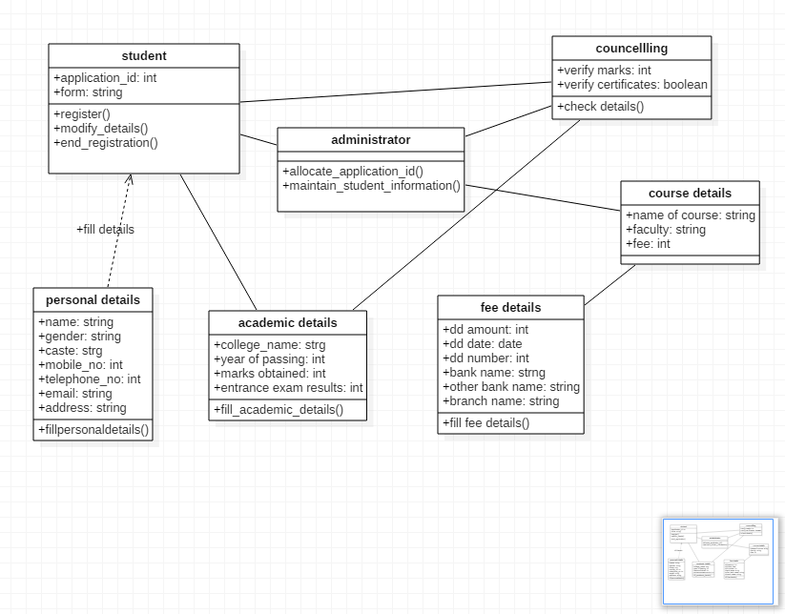

**Activity diagram**:

Activity diagram is basically a flow chart to represent the flow form one activity to another activity. The activity can be described as an operation of the system. So the control flow is drawn from one operation to another.

**Activity diagram for admission form of students:**

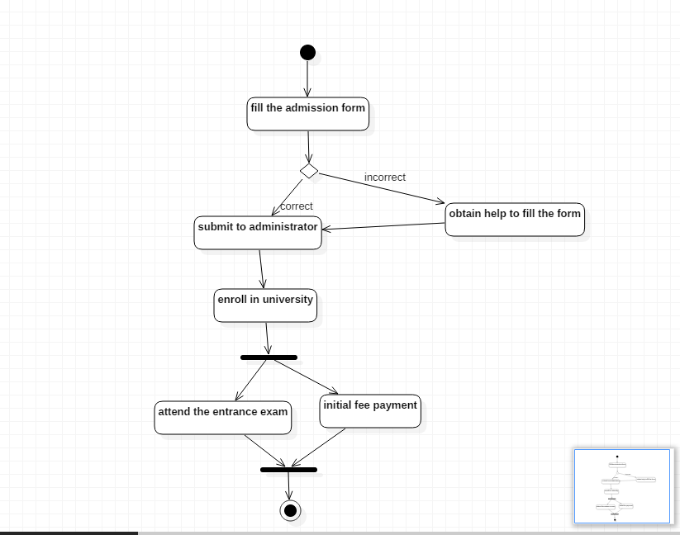

**Activity diagram for administrator and fee payment**

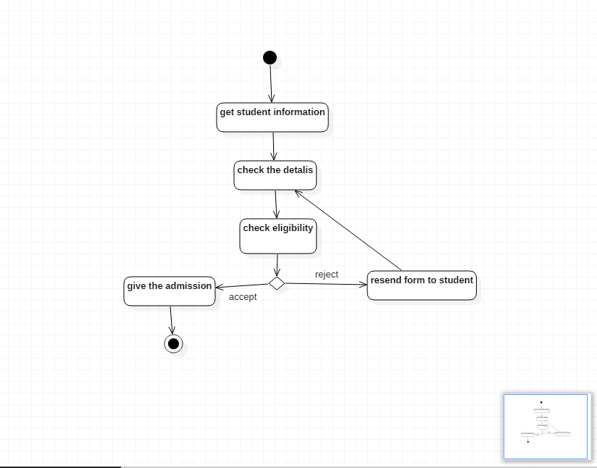

**SEQUENCE DIAGRAM:**

In sequence diagram, we use lifelines and messages which show the working and process which is going between the persons.

OBJECT NAMES

Student

Admission

Management

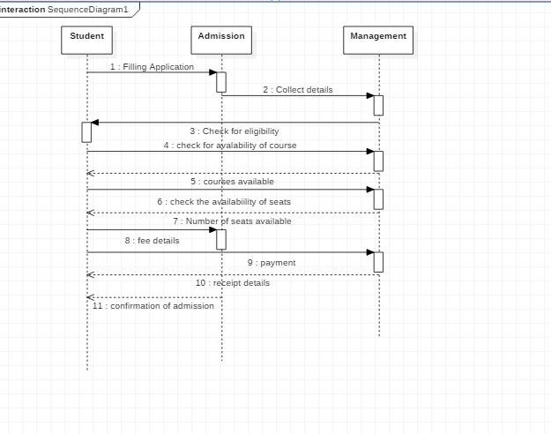

**5. CONCLUSION:**

Here by using Star Uml, we have drawn the diagrams and implemented a University Admission process System and shown the criteria which is going on and these helps to develop a software for the project. A computerized system provides flexibility, effectiveness and efficiency, plus it proves to be economical in the long run. The proposed university admission management system integrates all the features of a web-based system. As per user requirements, new features and modules can be added to the system.